5-2 Milestone Four: Enhancement Three Narrative

Katelyn Kincaid

Southern New Hampshire University: CS-499

5-2 Milestone Four: Enhancement Three Narrative

The artifact I chose to work on was the final project I submitted for CS-350: Emerging Systems Architectures and Technologies in October 2020. The objective of this project, titled ‘Weather,’ was to use RaspberryPi and GrovePi to create a device that would record light levels, temperature, and humidity levels. Using those inputs, you were then expected to send all applicable data to a JSON file using specific conditions. In the case of this project, one condition was to only record temperature data if it were during the day.

This project was selected for the Database enhancement because I wanted to see if I could integrate MongoDB to a project outside of Codio—the website used when learning about MongoDB. I also wanted to introduce a different way to view the data collected by the weather device. Unlike the previous week, the entirety of this week’s enhancement was spent in the “interactive shell” of raspberry pi, instead of the “LXDE Desktop” that I would typically use when developing this project.

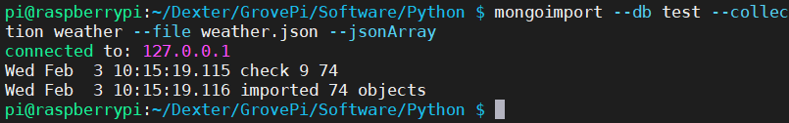

After downloading MongoDB, I had to import the json file I created the previous week. With the file imported, I then needed to verify that the information could be displayed using MongoDB.

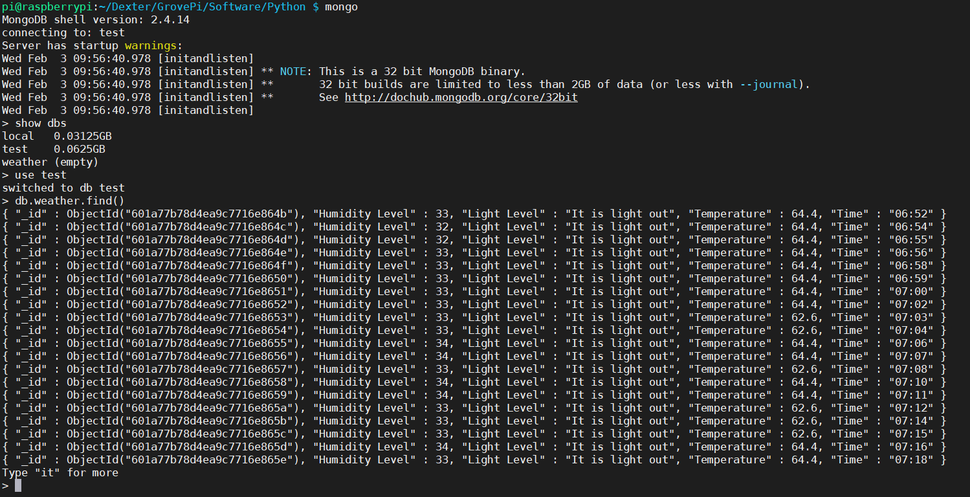

You can see my full sequence of commands above. There was a lot to the JSON file, so to see the full contents you would need to type “it” several times. When I first sat down and decided what specific enhancements I wanted to make to my previous final projects, I had decided that I just wanted to see if I could integrate MongoDB into a project I completed through RaspberryPi. That has proven to be a success.

By integrating MongoDB into my project, I’ve given myself more flexibility with querying my files. Initially, I would have to use an HTML5 static canvas to view this data, and it would be done so out of the RaspberryPi desktop. I could have also simply opened up the JSON file, but the method used above condenses it down to something much easier to read at a glance (i.e. all of the unnecessary spaces have been omitted). This is simply one more method of viewing the data collected.

Since the only objective in this enhancement was to successfully integrate MongoDB, I think it’s safe to say that the objective has been met. I don’t have any further plans for this enhancement at this time—I think what has been accomplished already is significant and worthwhile.

While I was attempting to accomplish this enhancement, I learned how to integrate MongoDB into an existing project. Before this enhancement, the only time I ever used MongoDB was for a course through Codio. I had never been forced to install it and then try to integrate it. I learned that it is truly an easy process and knowing this I think I will be more inclined to integrate MongoDB into future projects.

Aside from that, I learned that I was quite out of practice with MongoDB commands. I had to look back at previous assignments that showed how I got certain results. After spending some time familiarizing myself with the commands, I was able to deliver the screenshots provided above depicting the success of this enhancement.